**Local Magnetic Field Promoted Photocatalytic Water Splitting with Remarkable Solar-to-Hydrogen Efficiency**

Yiyang Li [1], Zihan Wang [2], Yiqi Wang[2], Andras Kovacs [3], Christopher Foo [1], Rafal Dunin-Borkowski [3], Yunhao Lu [2], Robert A. Taylor [4], Chen Wu [2]*, Shik Chi Edman Tsang [1]*

[1] Wolfson Catalysis Centre, Department of Chemistry, University of Oxford, Oxford, OX1 3QR, UK

[2] School of Materials Science and Engineering, State Key Laboratory of Silicon Materials, Zhejiang University, Hangzhou, 310027, China

[3] Peter Gruenberg Institute, Research Centre Juelich, 52425 Juelich, Germany

[4] Clarendon Laboratory, Department of Physics, University of Oxford, Oxford, OX1 3PU, UK

*Correspondence to: [edman.tsang@chem.ox.ac.uk](mailto:edman.tsang@chem.ox.ac.uk); chen_wu@zju.edu.cn

**Abstract: The capture and conversion of solar energy are recognised as a promising strategy to overcome energy crisis and mitigate related environmental issues. Therefore, photocatalytic overall water splitting (POWS) reaction for hydrogen evolution becomes increasingly attractive. Various systems for this reaction have been developed over the last decades, whereas their performances remain unsatisfactory due to the slow generation but fast recombination of charge carriers during the photocatalytic process. Herein, we report a dramatically improved H2 production activity of a N-doped TiO2 based photocatalyst via the introduction of local magnetic field by mixing the catalyst in close proximity to superparamagnetic nanoparticles under external magnetic field. Extraordinary hydrogen evolution rate of 20.6 mmol g-1 h-1 and quantum efficiency (QE) of 90.3% in visible light regime (437 nm) are obtained at elevated temperature without using any sacrificial reagent due to the rapid generation of the charge carriers with their prolonged lifetime in this material under the strong local magnetic flux. The solar-to-hydrogen (STH) conversion efficiency of 12.2% is also achieved under AM 1.5G simulated solar illumination, which, to the best of our knowledge, surpasses all reported results of particulate POWS systems so far. Moreover, this remarkable STH efficiency also reaches the requirement of practical applications of the POWS system.**

**Keywords:** Photocatalysis; superparamagnetic nanoparticles; hydrogen evolution; water splitting; magnetic field effect

1. **Introduction**

Storage of solar energy and conversion to chemical energy by photocatalytic processes have become a promising strategy to mitigate the energy crisis in recent years, which makes the photocatalytic overall water splitting (POWS) reaction attract increasing attention all around the world. With the help of proper photocatalysts, oxygen and hydrogen are produced from water stoichiometrically via POWS reaction and the solar energy is therefore stored in the form of hydrogen, which is an attractive carbon-emission-free chemical fuel with high energy density of 143 MJ kg-1 1–3. Consequently, various solar-to-hydrogen (STH) conversion approaches have been developed, among which the particulate photocatalytic systems show great potential for scale-up, meanwhile, such powder-based systems require less complicated set-up and less capital cost compared with photovoltaic-electrolysis (PV-E) or photoelectrochemical (PEC) systems4. However, the STH efficiencies of currently reported POWS systems still fall far behind the application requirements due to the intrinsic slow generation but fast recombination of photo-generated charge carriers of the semiconductor materials used. It should be noted that the STH efficiency is related to the bandgap of photocatalysts and the quantum efficiencies (QEs). Assuming the QEs of 100 %, the theoretical limit of a semiconductor with a bandgap of 2.0 eV is 17.9%; and narrower bandgap of 1.23 eV can result in a higher theoretical limit of ca. 45%, assuming all the absorbed photons are converted to hydrogen5,6. Qian et al. developed a Z-scheme POWS system showing a STH efficiency of 1.1%7, and recent studies pushed the value to around 5% 8,9. Despite the great progress achieved so far, the STH of particulate POWS systems still fails to meet the goal of 10% proposed by the United States Department of Energy (DOE)10. Apparently, some novel strategies to harvest the solar energy more efficiently are urgently required.

Most studies focus on achieving wider range of light absorption of the catalysts, however, it is recognised recently that broadened absorption range would not necessarily lead to improved performance11. Actually for reactions like POWS which involve multiple electrons and holes in the redox reactions, the photo-generated charge carriers must have sufficient lifetimes to travel to the surface and accumulate at active centres to allow the chemical reactions to take place12. Therefore, facilitating the separation of charge carriers is more important in this system, so that the photo-generated electrons and holes can participate the surface reactions instead of recombining to generate heat. Conventional approaches to prolong the exciton lifetimes include the fabrication of heterojunctions13–15 or Z-scheme systems7,16–18 in which the built-in electric field is introduced at the interfaces. Such methods need complicated construction of the materials and very fine control of the experimental parameters. We have recently reported that using elevated temperature, the photogeneration of charge carriers for water splitting can be much enhanced facilitated with the heat derived from the solar means11 (see SI). Novel strategies such as utilisation of external electric field to the prolong the recombination of the charge carriers generated at elevated temperature is proved effective in promoting catalytic performance19. Our approach to generate local electric field by using polar-faceted supports demonstrated prolonged exciton lifetimes and improved POWS activities at 270 oC, and we also illustrated the remarkable temperature effect which led to enhanced water dissociation and facilitated reaction kinetics11. The use of magnetic field as a non-contact technique has also been studied in various chemical reactions since 1920s20–22, however, the magnetic field effects (MFEs) have scarcely been explored in POWS reaction, because it is generally believed that Zeeman energy produced by magnetic field is negligible compared with Gibbs free energy of POWS (ca. 273 kJ mol-1), thus it cannot alter direct excitation hence no significant contribution23. Thus, the MFEs has only been briefly studied in other photocatalytic reactions24.

Here, we report a strong induced local magnetic-field-promoted POWS system, in which hydrogen and oxygen evolution activities are efficiently generated in a stoichiometric 2:1 ratio from pure water under visible light irradiation at 270 oC. By placing nitrogen-doped TiO2 photocatalyst in proximity to superparamagnetic Fe3O4 nanoparticles under external magnetic field. It is shown that the strong local magnetic field can lead to an extraordinary hydrogen evolution rate of 20.5 mmol g-1 h-1 and QE of 90.3% at 437 nm. The photocatalytic performance was also evaluated with simulated solar light irradiation (AM 1.5G), which gives an unprecedented STH efficiency of 12.2%, exceeding the practical application target of 10% imposed by the DOE10. We attribute this result to the dramatic prolonged time for charge carriers recombination of this N-doped photocatalyst of strong spin-polarized band for spin flipping as well as magnetic induced Lorentz force for the charges separation during illumination, which facilitate the alternative elementary reaction routes for water splitting in high rate to charge relaxation at elevated temperature.

1. **Results and Discussion**

To enhance the local magnetic flux applied to a metal oxide based photocatalyst under external magnetic field, magnetic Fe3O4 NPs encapsulated in silica were initially synthesised using the method adopted from our previous study25 as shown in Fig. 1a. High-resolution transmission electron microscopy (HRTEM) image confirms the lattice spacing of 0.298 nm, which corresponds to the (220) plane of Fe3O4 structure (Supplementary Fig. 1a). TEM clearly shows the well-dispersed Fe3O4 NPs have been synthesised with a high crystallinity (Fig. 1b), which are successfully encapsulated in silica (denoted as Fe3O4@SiO2), as shown in Supplementary Fig. 1b. It is unfortunate that Fe3O4@SiO2 did not show photocatalytic activity under visible light irradiation due to its large band gap of the silica. As mentioned before, our previous study demonstrated that N-doped TiO2 showed an outstanding performance toward the POWS reaction at elevated temperature11,26. Therefore, the Fe3O4 NPs was then combined with TiO2 via a sol-gel process, followed by high temperature ammonia treatment for the nitrogen doping, where the designate content of Fe3O4 is 20% (denoted as Fe3O4/N-TiO2-2) (the magnetic particles encapsulated in TiO2 matrix with a degree of aggregation can be seen in Fig. 1d, Supplementary Fig. 3 and Supplementary Fig. 4). XRD indicated the existence of anatase phase TiO2, and no phase transformation to rutile phase during ammonia treatment was observed (Fig. 1c). Depth-profiling X-ray photoelectron spectroscopy (XPS) was performed to investigate the distribution of chemical species of Fe3O4/N-TiO2-2. The sample was etched by ion-beam for different time periods so as to obtain the chemical information from surface/subsurface to inner region. Typical XPS survey spectrum shows peaks of N 1s, O 1s, Ti 2p and Fe 2p, as shown in Fig. 1e and Supplementary Fig. 5. Moreover, the Fe 2p peaks show an increasing trend when the sample is sputtered (Fig. 1f and Supplementary Table 2), indicating the Fe3O4 NPs are mostly encapsulated in the N-doped TiO2. More details about the oxide encapsulated Fe3O4 NPs are available in Supplementary Note 2.

**Figure 1 a** Simplified schematic illustration of the synthesis procedure of Fe3O4 NPs and the encapsulated Fe3O4 photocatalysts. Detailed synthesis procedure is given in the Supplementary Information; **b** TEM images ofFe3O4 NPs (8 nm); **c** XRD patterns of Fe3O4 NPs, Fe3O4/N-TiO2-2 and N-TiO2. XRD measurements were performed on a Bruker D8 Advance diffractometer and Cu Kα1 radiation (λ= 1.5406 Å). Samples were scanned at 2 angles of 5-90o; **d** HR-TEM ofFe3O4/N-TiO2-2 photocatalyst. Red circles indicate the 8 nm Fe3O4 NPs and yellow circle indicates the region of N-TiO2 with d-spacings shown in the image. Details can be found in Supplementary Fig. 1 and Supplementary Fig. 4; **e** XPS survey spectra of Fe3O4/N-TiO2-2; **f** Fe 2p XPS spectra of Fe3O4/N-TiO2-2 obtained at different ion-sputtering time; **g** magnetisation curves of Fe3O4 NPs, Fe3O4/N-TiO2-2 and N-TiO2. Static magnetic properties of samples were measured using a superconducting quantum interference device (SQUID, Quantum Design MPMS-XL-5).

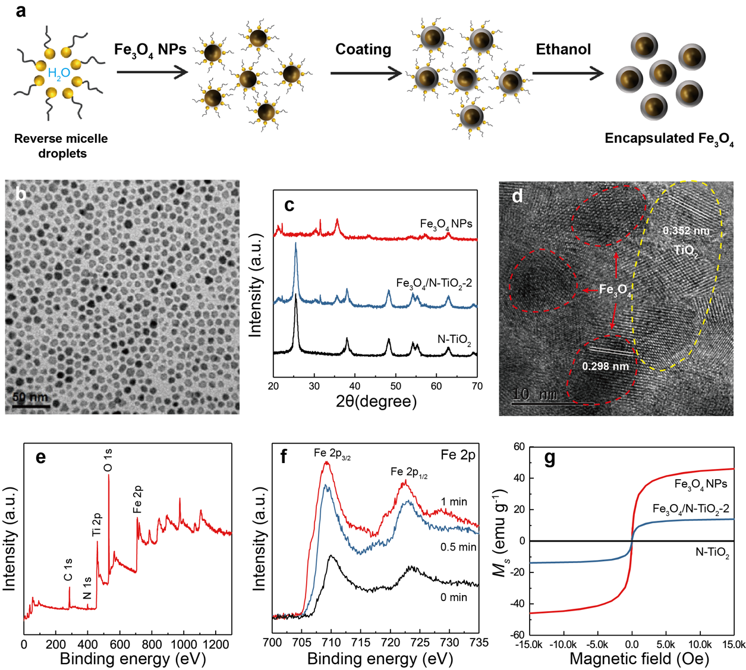

The photocatalytic performances of the as-prepared photocatalysts were then evaluated for the POWS reaction in a closed batch reactor at 270 oC. Our recent study shows that for N-TiO2 based photocatalysts, the POWS performance is greatly dependent on the temperature11: the hydrogen evolution rate increases with the temperature and reaches the optimal activity at around 270 oC following the change in water dissociation constant. Systematic EPR study implied that the oxygen mobility and re-generation of the charged oxygen vacancies were greatly facilitated at elevated temperatures to facilitate a rapid photo water splitting11. More information on photocatalysis at elevated temperatures is shown in Supplementary Note 1.

Initial experiments were performed over N-TiO2 and Fe3O4/N-TiO2-2 photocatalysts without external magnetic field (all photocatalysts are used after deposition of 1 wt.% of Au via photo-reduction method), both of which showed good performance toward POWS, giving similar hydrogen evolution rates of around 7000 µmol g-1 h-1 (Supplementary Table 3). The Fe3O4 NPs and Fe3O4@SiO2 were both tested alone, showing no detectable hydrogen evolution, which indicates the Fe3O4 has no contribution to the POWS activity under this condition. Subsequently, to study the MFE on the POWS system, external static magnetic field of 1500 Oe was applied by fixing a permanent magnet near the reactor during the testing. Excitingly, the POWS activity of Fe3O4/N-TiO2-2 increased to 12,210 µmol g-1 h-1, showing 76% of enhancement. On the contrary, the photocatalytic activity of the N-TiO2 remains almost the same. The lack of detectable change of N-TiO2 in response to external magnetic field indicates its weak local field flux density, whereas superparamagnetic Fe3O4 nanoparticles can generate much stronger local field flux after magnetisation.

The M-H curve of the Fe3O4/N-TiO2-2 in Fig. 1g exhibited superparamagnetic nature, in which case a strong local magnetic field could clearly be induced by the external field, while no obvious induced magnetisation was detected over N-TiO2. The influence of electron transfer between N-TiO2 and Fe3O4 NPs was excluded by introducing an insulated silica layer in between (Fe3O4@SiO2/N-TiO2), which showed similar POWS activity as that of Fe3O4/N-TiO2-2. The photocatalytic performance shows a decreasing trend as the field strength is reduced (Fig. 2a). Similarly, Fig. 2b shows the saturated magnetisation value varies with the Fe3O4 NPs content.

The POWS activities were then tested at 270 oC as well under visible light irradiation with an external magnetic field of 1500 Oe. Fig. 2c clearly indicates that the magnetic photocatalysts become more sensitive to the external magnetic field as the content of the Fe3O4 NPs increasing.

**Figure 2** Characterisation and activity tests of the Fe3O4/N-TiO2 photocatalysts. **a** POWS activity tests of Fe3O4/N-TiO2-2 under external magnetic field of different strengths. **b** magnetisation curves of Fe3O4/N-TiO2-1, Fe3O4/N-TiO2-2, Fe3O4/N-TiO2-3 and Fe3O4/N-TiO2-4 photocatalysts; **c** POWS activity tests of N-TiO2, Fe3O4/N-TiO2-1, Fe3O4/N-TiO2-2, Fe3O4/N-TiO2-3 and Fe3O4/N-TiO2-4 photocatalysts with or without external magnetic field. (NMF=no magnetic field, MF=magnetic field (1500 Oe)). The POWS reactions were carried out in a close stainless-steel autoclave equipped with two quartz windows. In a typical experiment, 1 wt.% Au was deposited onto the photocatalysts via photo-reduction method, and certain amount of resulted material which contains 5 mg of TiO2 is added to 10 mL of Milli-Q H2O under vigorous magnetic stirring (600 rpm); then the autoclave was sealed and heated up to 270 oC. Tungsten light (70W, Glamox Professional 2000) was then applied to provide visible-light irradiation, and external magnetic field was supplied by a permanent magnet. The amounts of hydrogen and oxygen were measured by gas chromatography (GC) after reactions. More details can be found in Supplementary Information. Error bars indicate the standard deviation.

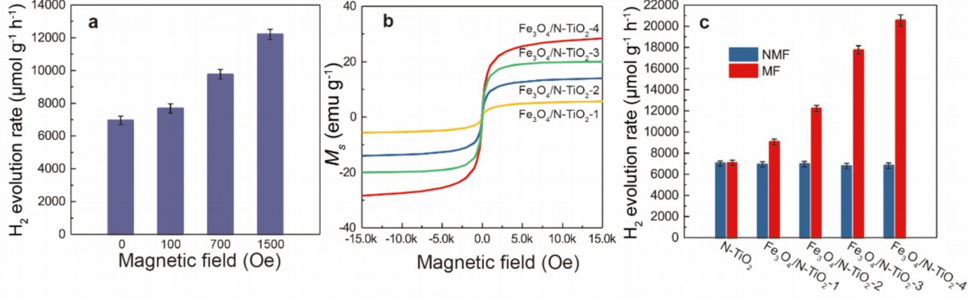

Time-resolved photoluminescence (TRPL) was then engaged to investigate the charge separation process with and without the magnetic field. As shown in Fig. 3a and Fig. 3b, it is obvious that both Fe3O4/N-TiO2-2 and N-TiO2 show similar exciton lifetimes without external magnetic field, while the exciton lifetime of Fe3O4/N-TiO2-2 was prolonged substantially when the magnetic field exists, and that of the pure N-TiO2 remain almost unchanged. Such difference of the response to the magnetic field coincides well with what was observed in the POWS activity tests. Subsequently, further TRPL experiments were carried out on Fe3O4/N-TiO2-2 photocatalyst under magnetic fields with different strengths as before. Not surprisingly, the exciton lifetime increased with the magnetic field strength, confirming that the exciton lifetime changes in response to the applied magnetic field which induce different local magnetic field strength, and also indicating that the charge separation process is more supressed under stronger induced magnetic field (Fig. 3c).

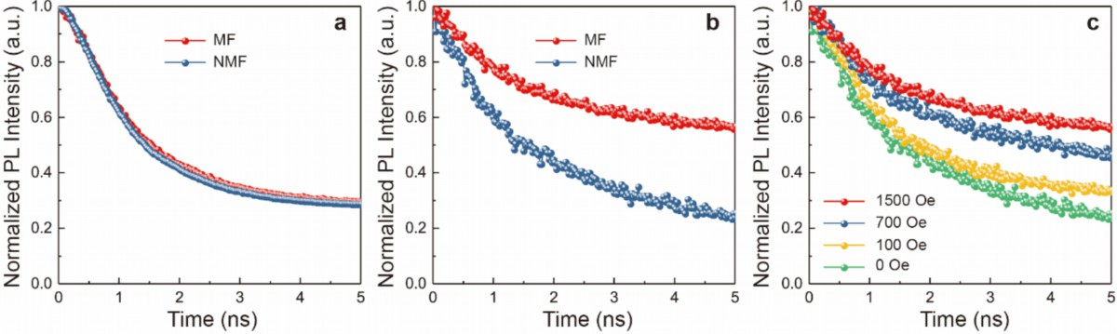

**Figure 3** Photoluminescence (PL) studies of the magnetic photocatalysts. **a** Time-resolved PL spectrum of N-TiO2 with or without external field; **b** Time-resolved PL spectra of Fe3O4/N-TiO2-2 with or without external field; **c** Comparison of the time-resolved PL spectra of Fe3O4/N-TiO2-2 under magnetic field of different strengths. (NMF=no magnetic field; MF=magnetic field). Photoluminescence spectra and corresponding lifetimes of excitons were obtained from a bespoke micro-photoluminescence setup, in which a Ti-Sapphire laser (λ = 266 nm, pulse duration = 150 fs, repetition rate = 76 MHz) is directed onto the sample. The exciton lifetime is obtained by fitting corresponding background-corrected PL spectrum with a mono-exponential decay function in the form y = A1exp(-x/t1) + y0. Error in the fitting is determined from its least square.

Photocatalysts with different iron oxide NPs contents were then tested, apparently, all the samples show similar TRPL spectra without external magnetic field (as shown in Fig. 4a-d, blue line and Fig. 4e). While when measured in a magnetic field of 1500 Oe, TRPL results show that the exciton lifetime was prolonged more substantially with higher content of iron oxide (Fig. 4a-d, red line and Fig. 4f), which is in accordance with the previous magnetisation experiments (Fig. 2b) and the POWS activity tests (Fig. 2c). The above observations indicate that the charge separation process is dominated by the local magnetic field induced by the external static magnetic field, therefore the non-magnetic N-TiO2 showed no significant response to the magnetic field. In addition, the MFEs become more substantial when the external magnetic field is stronger, because stronger external field induces stronger local magnetic field according to the magnetisation experiments (Fig. 2b). This could also explain that for a fixed external field, the samples contain more iron oxide show higher response to the field.

It is known that charge bodies in motion can be affected by Lorentz force by an external magnetic field, and the excited negatively electrons and positively holes of the coated N-TiO2 encapsulated on the magnetite NPs at close proximity will experience the Lorentz forces in opposite direction with a stronger local magnetic field ((see Supplementary Fig. 11) to account for their longer recombination lifetimes.

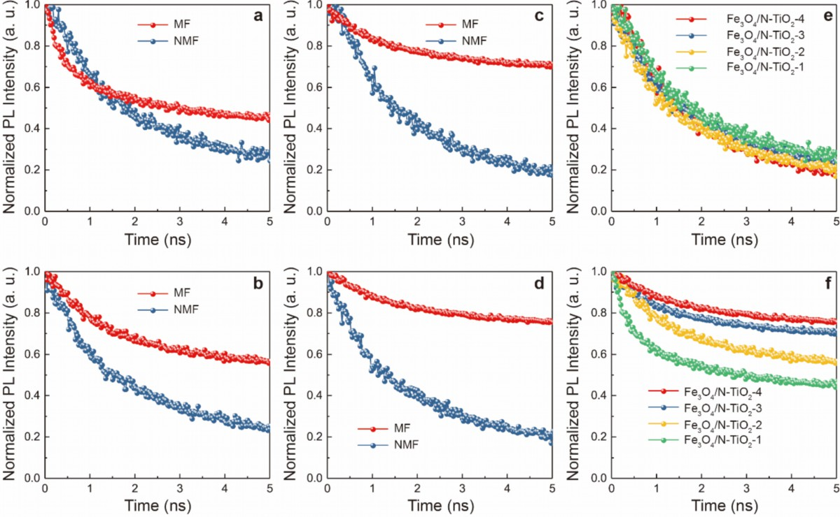

**Figure 4** Time-resolved Photoluminescence study of the Fe3O4/N-TiO2 materials. Time-resolved photoluminescence (TRPL) spectra of **a** Fe3O4/N-TiO2-1, **b** Fe3O4/N-TiO2-2, **c** Fe3O4/N-TiO2-3 and **d** Fe3O4/N-TiO2-4 measured with and without external magnetic field; Comparison of the TRPL spectra of Fe3O4/N-TiO2-1, Fe3O4/N-TiO2-2, Fe3O4/N-TiO2-3 and Fe3O4/N-TiO2-4 **e** without magnetic field and **f** with magnetic field. (NMF=no magnetic field; MF=magnetic field) The exciton lifetimes of the photocatalysts are summarized in Supplementary Table 4.

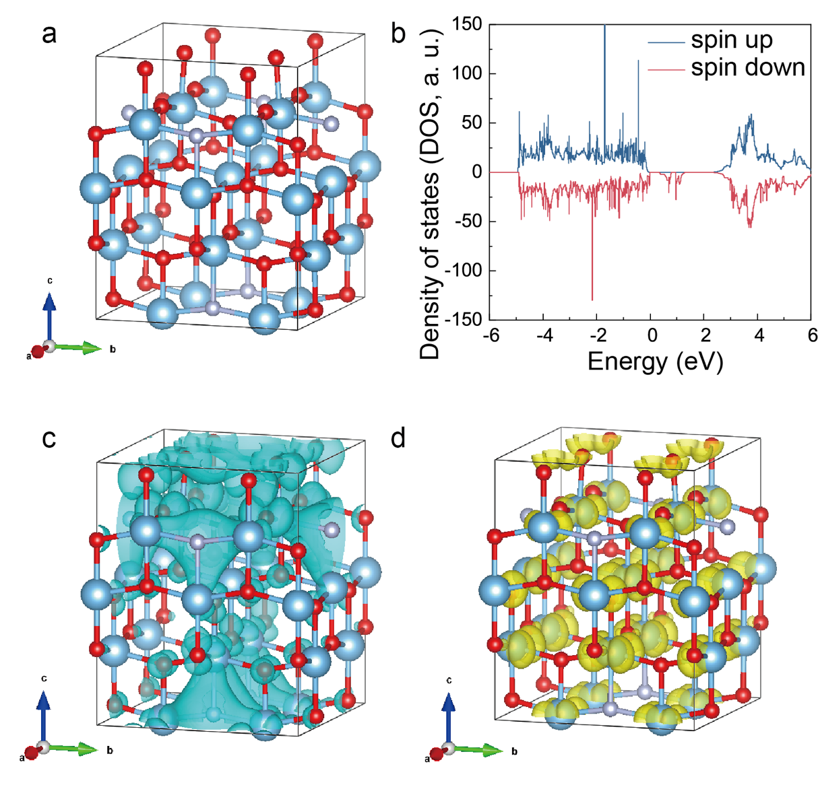

**Figure 5** DFT calculations of the local magnetic field effect on N-doped TiO2 photocatalyst. **a** The constructedTi16O28N4supercell for DFT calculation (O: red; Ti: blue; N: purple); **b** Calculated total density of states (DOS) of Ti16O28N4 supercell with magnetic field (ferromagnetic state); **c** 3D spatial distributions of spin polarisation of N-doped Ti16O28N4 model in defect band under ferromagnetic state. The blue surfaces indicate the charge density of spin-down electrons; **d** Calculated partial charge density of conduction band minimum (CBM) under ferromagnetic state. The value of iso-surface is set to be 0.001eV/Å. The yellow surfaces represent the total electron densities near each atom.

Interestingly, we also note that from the net magnetisation curve, this composite material can give induced ferromagnetism (FM) with remanence and coercivity at zero driving field, which implies the cooperative alignment of charge bodies in the material under magnetic field may also influence the POWS performance along with the Lorentz force on isolated charge bodies. It has been reported that substitution of oxygen by nitrogen in N-doped TiO2 can generate defective holes and the hole-mediated double exchange through the strong p-p interaction between N and O can give spins correlation to this material 27. Therefore, a Ti16O28N4 supercell based on structure of N-doped anatase TiO2 with ca. 4.4 wt.% N-doping 28 was constructed and studied by first-principles DFT calculations, as shown in Fig. 5a. The calculated total density of states (DOS) of ferromagnetic (FM) state under magnetic field (shown in Fig. 5b and Supplementary Fig. 12a) clearly indicates that the defect state is created within the bandgap near the Fermi level, which are mainly originated from doped N atoms. It also appears that these defect states are not localised as in the previously study but form an extensive band due to the interaction between N atoms at our high doping concentration, which may account for the enhanced visible light absorption29.From the distribution of the defect state on two spin channels, only one spin channel occurs in the bandgap of N-doped TiO2 under FM state indicative that the magnetic moments are well-aligned in the material in valence band (VB), showing an obvious spin polarisation (Fig. 5b and 5c). Meanwhile, the magnetic states show little effect on the conduction band (CB) (Fig. 5d). Clearly, in the presence of an induced local magnetic field generated by the Fe3O4 NPs, the cooperative magnetic moments in N-TiO2 are parallelly aligned and become FM state under the high spatial spin polarised environment (Fig. 5c). When an electron is excited to CB, it is likely to undergo spin relaxation during the transfer, losing its original spin characteristic and changing to the other state, due to spin-orbital coupling, hyperfine interaction, etc.30 Upon recombination, the slow process of spin flipping and opposite Lorentz forces, resulting in a prolonged exciton lifetime, as observed by our TRPL and illustrated in Fig. 6a. The prolonged lifetimes of the photogenerated charged species reduce their chance for recombination, enhance the diffusion to surface and greatly facilitate the H+ reduction and OH̶ oxidation from water 29.

Concerning the potential of practical applications of a POWS system, QE and STH efficiency are widely recognised as parameters that can be directly compared when evaluating different POWS systems31. QE is the ratio of the number of H2 molecules evolved to the number of photons of a given energy that shines on the photocatalyst. So, it is normally measured at a certain wavelength rather than a wide spectrum, so as to understand the behaviours of a photocatalytic system at different wavelengths. While STH is a standardised index focusing on the overall energy conversion efficiency from the solar energy to chemical energy. In this work, QEs of Fe3O4/N-TiO2-4 were evaluated at different wavelengths using a 300W Xe lamp installed with bandpass filters of different wavelengths, and STH was tested under the irradiation of simulated AM 1.5G solar light generated by a VeraSol solar simulator with the power of 100 mW cm-2 (1 Sun). Fig. 6b clearly shows that N-TiO2, although shows good QE at 437 nm, remains uninfluenced by the use of external magnetic field. The results shown in Fig. 6c present an impressive QE of 77.3% at 437 nm without external magnetic field over Fe3O4/N-TiO2-4, while the QEs dropped at longer wavelengths. Excitingly, when the external magnetic field was applied, the QEs of each wavelength increased to different extent, giving an extraordinary QE of 90.3% at 437 nm (Supplementary Note 3), and the QE at 750 nm was increased by more than 3 times, as shown in Fig. 6c. Moreover, a QE of 24.1% can be obtained even at NIR regime of 1000 nm. Additionally, using Fe3O4/N-TiO2-4 photocatalyst, an extraordinary STH of 12.2% was also achieved from such POWS system in a magnetic field of 1500 Oe, which, to the best of our knowledge, surpasses all the reported values in similar particulate systems (Supplementary Table 5and Supplementary Note 4). Stability of the Fe3O4/N-TiO2-4 photocatalyst was also evaluated by recycling the catalysts for 5 times, which showed no obvious change of the photocatalytic activities (Fig. 6d).

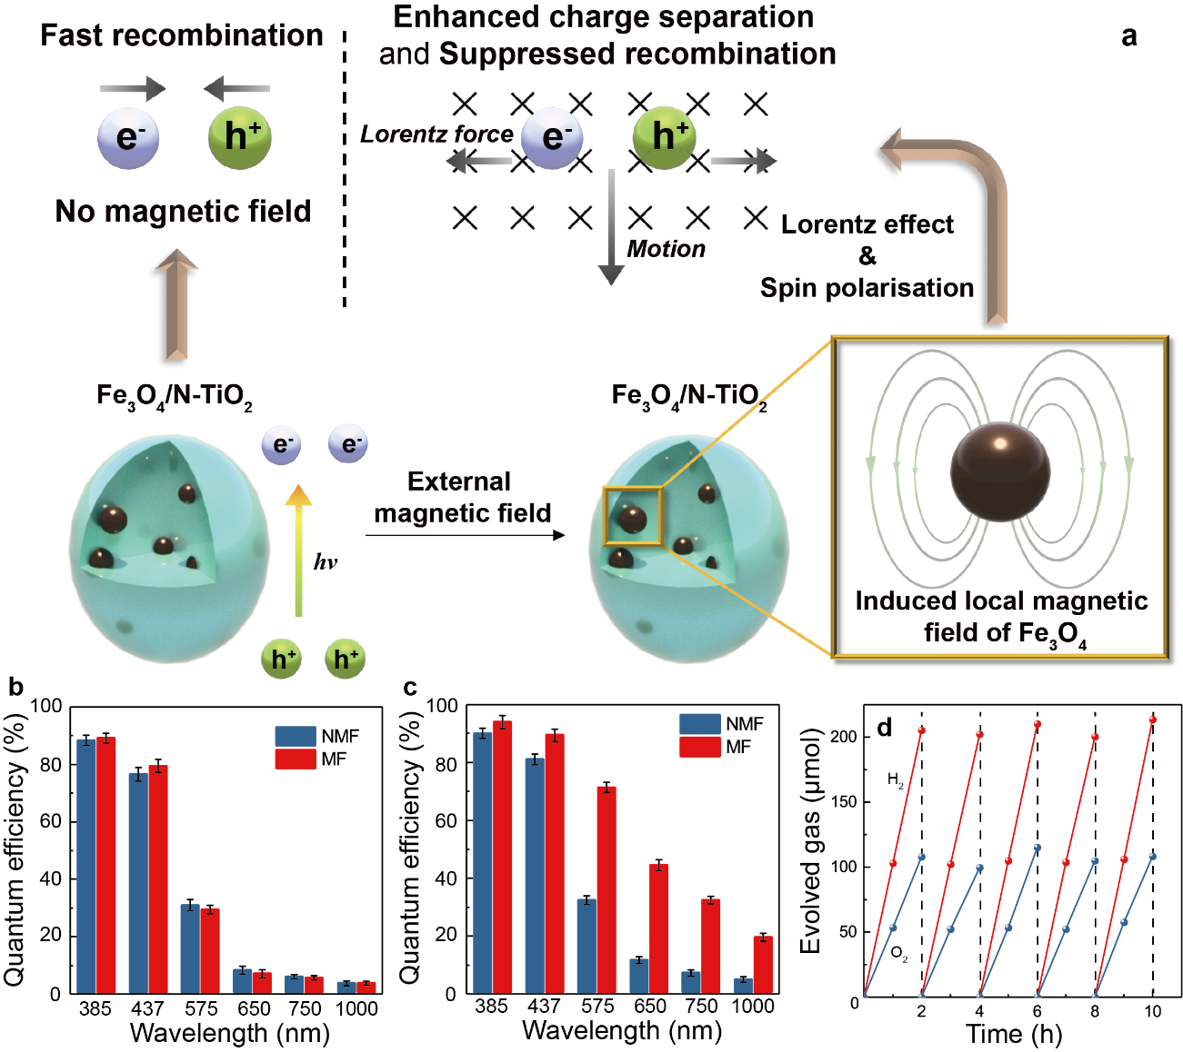

**Figure 6** Proposed mechanism and QE tests of the POWS system. **a** Schematic illustration of the magnetic field promoted POWS system, in which the charge separation process is facilitated by the induced local magnetic field; QE of N-TiO2 **(b)** and Fe3O4/N-TiO2-4 **(c)** photocatalysts with and without external magnetic field. (NMF=no magnetic field; MF=magnetic field) The apparent QE was measured in the same autoclave and was evaluated by adding certain amount of photocatalyst which contains 50 mg of TiO2 to 10 mL of Milli-Q H2O, then it was irradiated by a 300W Xenon lamp equipped with bandpass filters of 437 ± 10, 575 ± 25, 650 ± 20 and 750 ± 20, respectively. Each photocatalyst was used after deposition of 1 wt.% Au via photo-reduction method. Numbers of photons were calculated from the irradiation powers in each wavelength region measured by a light metre at the corresponding wavelengths. Error bars indicate the standard deviation; **d** Repeatable tests of Fe3O4/N-TiO2-4 photocatalyst at 270 oC and 1500 Oe for 2 h followed by cooling to room temperature in each cycle, respectively.

1. **Conclusion**

To summarize, exceptional hydrogen evolution rate of 20550 µmol g-1 h-1and QE of 90.3% at 437 nm at 270oC are obtained over the Fe3O4 encapsulated in N-TiO2 photocatalyst with an external magnetic field of 1500 Oe. More than ca. 200 % enhancement in exciton lifetimes is recorded along with the outstanding POWS performance over this magnetic composite. Unprecedented STH of 12.2% can be achieved, which surpasses all the reported STH of particulate POWS systems, leading the POWS system closer to the practical applications. This STH efficiency is even comparable with the PV-E and PEC systems (Supplementary Table 5), while this particulate POWS system has the advantage of simple set-up and anticipated low capital costs. Further optimisation could be made by placing a selected photocatalyst in nano-engineered support capsules in close proximity using stronger superparamagnetic Fe alloys nanomaterials. It is believed that the magnetic field effects discussed in this work can be potentially adopted to other photocatalytic systems and further contribute to the rational design of photocatalysts.

**Data availability**

The source data are all shown in Supplementary Figs. 1-13, Supplementary Tables 1-5 and Supplementary Notes 1-4. All relevant data are available from the authors.

**References**

1. Zhou, G. *et al.* Photoinduced semiconductor-metal transition in ultrathin troilite FeS nanosheets to trigger efficient hydrogen evolution. *Nat. Commun.* **10**, 399 (2019).

2. Chen, X., Shen, S., Guo, L. & Mao, S. S. Semiconductor-based photocatalytic hydrogen generation. *Chem. Rev.* **110**, 6503–6570 (2010).

3. Li, Q. *et al.* Highly efficient visible-light-driven photocatalytic hydrogen production of CdS-cluster-decorated graphene nanosheets. *J. Am. Chem. Soc.* **133**, 10878–10884 (2011).

4. Hisatomi, T. & Domen, K. Reaction systems for solar hydrogen production via water splitting with particulate semiconductor photocatalysts. *Nat. Catal.* **2**, 387–399 (2019).

5. Keene, S., Bala Chandran, R. & Ardo, S. Calculations of theoretical efficiencies for electrochemically-mediated tandem solar water splitting as a function of bandgap energies and redox shuttle potential. *Energy Environ. Sci.* **12**, 261–272 (2019).

6. Wang, S., Liu, G. & Wang, L. Crystal Facet Engineering of Photoelectrodes for Photoelectrochemical Water Splitting. *Chem. Rev.* **119**, 5192–5247 (2019).

7. Wang, Q. *et al.* Scalable water splitting on particulate photocatalyst sheets with a solar-to-hydrogen energy conversion efficiency exceeding 1%. *Nat. Mater.* **15**, 611–615 (2016).

8. Liao, L. *et al.* Efficient solar water-splitting using a nanocrystalline CoO photocatalyst. *Nat. Nanotechnol.* **9**, 69–73 (2014).

9. Tian, B. *et al.* Supported black phosphorus nanosheets as hydrogen-evolving photocatalyst achieving 5.4% energy conversion efficiency at 353 K. *Nat. Commun.* **9**, 1397 (2018).

10. Wang, Q. & Domen, K. Particulate Photocatalysts for Light-Driven Water Splitting: Mechanisms, Challenges, and Design Strategies. *Chem. Rev.* **120**, 919–985 (2020).

11. Li, Y. *et al.* Photocatalytic water splitting by N-TiO2 on MgO (111) with exceptional quantum efficiencies at elevated temperatures. *Nat. Commun.* **10**, 4421 (2019).

12. Wolff, C. M. *et al.* All-in-one visible-light-driven water splitting by combining nanoparticulate and molecular co-catalysts on CdS nanorods. *Nat. Energy* **3**, 862–869 (2018).

13. Low, J., Yu, J., Jaroniec, M., Wageh, S. & Al-Ghamdi, A. A. Heterojunction Photocatalysts. *Adv. Mater.* **29**, 1601694 (2017).

14. Shang, L. *et al.* CdS Nanoparticle-Decorated Cd Nanosheets for Efficient Visible Light-Driven Photocatalytic Hydrogen Evolution. *Adv. Energy Mater.* **6**, 1501241 (2016).

15. Pan, C., Xu, J., Wang, Y., Li, D. & Zhu, Y. Dramatic activity of C3N4/BiPO4 photocatalyst with core/shell structure formed by self-assembly. *Adv. Funct. Mater.* **22**, 1518–1524 (2012).

16. Tada, H., Mitsui, T., Kiyonaga, T., Akita, T. & Tanaka, K. All-solid-state Z-scheme in CdS-Au-TiO2 three-component nanojunction system. *Nat. Mater.* **5**, 782–786 (2006).

17. Zhang, Z. *et al.* A Nonmetal Plasmonic Z-Scheme Photocatalyst with UV- to NIR-Driven Photocatalytic Protons Reduction. *Adv. Mater.* **29**, 1606688 (2017).

18. Wang, Q. *et al.* Printable Photocatalyst Sheets Incorporating a Transparent Conductive Mediator for Z-Scheme Water Splitting. *Joule* **2**, 2667–2680 (2018).

19. Hou, W. & Cronin, S. B. A review of surface plasmon resonance-enhanced photocatalysis. *Adv. Funct. Mater.* **23**, 1612–1619 (2013).

20. Selwood, P. W. Magnetism and catalysis. *Chem. Rev.* **38**, 41–82 (1946).

21. Steiner, U. E. & Ulrich, T. Magnetic Field Effects in Chemical Kinetics and Related Phenomena. *Chem. Rev.* **89**, 51–147 (1989).

22. Okumura, H., Endo, S., Joonwichien, S., Yamasue, E. & Ishihara, K. N. Magnetic field effect on heterogeneous photocatalysis. *Catal. Today* **258**, 634–647 (2015).

23. Li, J. *et al.* Enhanced Photocatalytic Performance through Magnetic Field Boosting Carrier Transport. *ACS Nano* **12**, 3351–3359 (2018).

24. Gao, W. *et al.* Suppressing Photoinduced Charge Recombination via the Lorentz Force in a Photocatalytic System. *Adv. Sci.* **6**, 1901244 (2019).

25. Peng, Y. K. *et al.* Engineering of Single Magnetic Particle Carrier for Living Brain Cell Imaging: A Tunable T1-/T2-/Dual-Modal Contrast Agent for Magnetic Resonance Imaging Application. *Chem. Mater.* **29**, 4411–4417 (2017).

26. Li, Y. & Tsang, S. C. E. Recent Progress and Strategies for Enhancing Photocatalytic Water Splitting. *Mater. Today Sustain.* **9**, 100032 (2020).

27. Tao, J. G. *et al.* Density functional study on ferromagnetism in nitrogen-doped anatase TiO2. *Appl. Phys. Lett.* **95**, 93–96 (2009).

28. Foo, C. *et al.* A Structural Study of TiO 2 powder phases with O Defects and N impurities on Photocatalytic Activity Using Variable-Temperature Synchrotron X- Ray Powder Diffraction. *Nat. Commun.* In press (2021).

29. Wang, W., Tadé, M. O. & Shao, Z. Nitrogen-doped simple and complex oxides for photocatalysis: A review. *Prog. Mater. Sci.* **92**, 33–63 (2018).

30. Pan, L. *et al.* Manipulating spin polarization of titanium dioxide for efficient photocatalysis. *Nat. Commun.* **11**, 418 (2020).

31. Wang, Z., Li, C. & Domen, K. Recent developments in heterogeneous photocatalysts for solar-driven overall water splitting. *Chem. Soc. Rev.* **48**, 2109–2125 (2019).

**Acknowledgments:**

The financial support for this project from the EPSRC in the United Kingdom (Grant EP/K040375/1) and the Zhejiang University Education Foundation Global Partnership Fund are kindly acknowledged.

**Authors’ contributions**:

Y.L. and C.F. prepared, characterised and tested the photocatalysts; Y.L., C.W. and Z.W. A.K. R.D.B. studied the magnetic properties of the materials; Y.L. collected and analysed the TRPL data with the help of R.A.T.; Y.L. and S.C.E.T. wrote the paper in discussion with C.W.; S.C.E.T. supervised the overall project.

**Conflict of interest:**

The authors claim no conflict of interest.